A Novel approach : Hand Gesture Recognition Software, for Machine Vision Purposes

Kaustubh Bhoir 21BAI1705 Class number : VIT Chennai kaustubhbhoi@gmail.coml

Sachin Jhawar 21BAI1186 Class number : VIT Chennai sachinjhawar3@gmail.com

Harshit Mahlavat 21BAI1634 Class

number : VIT Chennai Harshita.mahlavat@vitstudent.ac.in

*AHand signal recognition is an innovative approach to enhancing human-computer interaction by enabling gesture-based communication. This system digitizes hand movements using image enhancement techniques, making interaction more intuitive and accessible. Machine vision methods like image segmentation and CNNs are employed for precise classification of gestures. The system demonstrates a high recognition rate, exceeding 90%, for predefined gestures.*

# Introduction (*Heading 1*)

This use of hand signal recognition software is involved in enhancing human computer interaction within the machine vision systems and is discussed in this paper on the development and execution of hand sign detection using machine vision methods. In this proposed system, the hand movements are detected and the input digitized through image enhancement techniques. It employs a neural network (CNN) for accurate classification. The paper identifies challenges like changing illumination conditions factors such as occlusion and the richness, in terms of hand shapes, encountered during classification tasks. The systems effectiveness is demonstrated through experiments showing a recognition rate of, than 90% for a group of predefined gestures. Keywords such as hand gestures and machine vision play a role in advancing human computer interaction through the use of neural networks for recognizing gestures. Hand movement recognition has been one of the current topics of interest in times due to various applications, in fields like virtual reality technology and sign language interpretation among many others. Hand movements can be an intuitive way for people to interact with computers making gesture-controlled interfaces more widespread. Computer vision technology, in this case, machine vision, applies when helping computers understand and process data, from their surroundings. Introduces a software program that is to recognize hand gestures in time through advanced machine vision techniques of using the specific term "hand signs", focus on creating a system that can swiftly and accurately recognize and understand hand gestures, research, into the development of software for reading hand gestures by employing techniques such as image enhancement and segmentation alongside CNN technology, for categorization.Ease of Use

measurement and others are deliberate, using specifications that anticipate your paper as one part of the entire proceedings, and not as an independent document. Please do not revise any of the current designations.

# Prepare Your Paper Before Styling

Before you begin to format your paper, first write and save the content as a separate text file. Complete all content and organizational editing before formatting. Please note sections A-D below for more information on proofreading, spelling and grammar.

Hand gesture classification is one of the significant problems researched in the context of machine vision applications. Traditionally, rule-based techniques were used where present day use learning-based techniques. Several scientists have proposed different techniques like Support Vector Machines SVM Hidden Markov Models HMM and CNN for classification of hand gestures. For instance, Zeng et al. (2018) used a depth camera for achieving hand gesture recognition accuracy but the need for equipment was there. In comparison with the above approaches, Wang et al. approaches in 2020 are related to real-time gesture recognition with some demands. The innovative system is evident from the combination of real-time functionality and a learning model using standard RGB cameras.

The dataset of hand signs was captured with a RGB camera in well-controlled lighting conditions. This dataset includes pictures illustrating hand gestures such as "thumbs up," "peace," and "stop." Each gesture category will have 1 000 images, differing in angles, proximity, and backdrop.

Before getting submerged, into the tasks, some preparation has to be done. Grayscale Conversion makes it easier by converting the input image to grayscale, thus reducing the complexity of the system.

Hand Detection and Segmentation Technique focuses on the removal of a picture's background area of hands, and then creating a mask based on thresholding. "Feature Extraction and Data Classification" The use of CNN architecture the characterization and hand signal classification, which comprised of; The input layer will have preprocessed images sizes are 64 by 64 pixels, in size. Convolutional layers help in capturing features using filters of sizes. Pooling layers help in reducing complexity while preserving features. The Connected Layer is responsible for performing classification based on the features that have been extracted. The softmax layer provides the probability scores of each gesture class.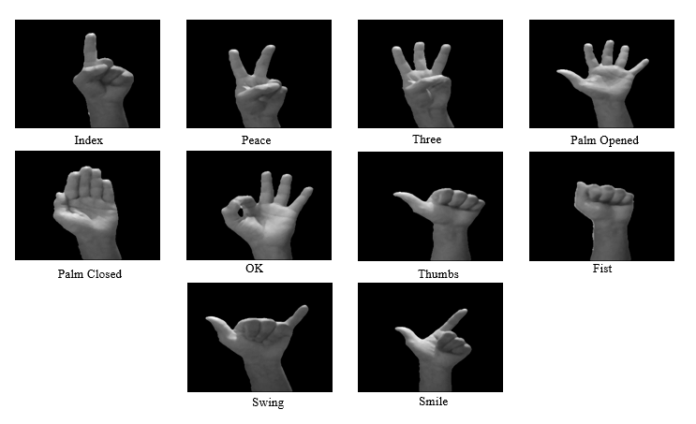

Hand Detection and Segmentation Technique focuses on the removal of a picture's background area of hands, and then creating a mask based on thresholding. "Feature Extraction and Data Classification" The use of CNN architecture the characterization and hand signal classification, which comprised of; The input layer will have preprocessed images sizes are 64 by 64 pixels, in size. Convolutional layers help in capturing features using filters of sizes. Pooling layers help in reducing complexity while preserving features. The Connected Layer is responsible for performing classification based on the features that have been extracted. The softmax layer provides the probability scores of each gesture class.

The Convolutional Neural Network is trained on the hand gestures dataset using backpropagation and an Adam optimizer technique, to be used for training and optimization. The dataset is divided into three categories: training set 70% validation set 15% and test set 15%. Methods for augmenting the learning process and making it even more efficient in recognizing hand signs are the data augmentation methods. For instance rotation scale adjustment and flipping.

The performance of the system is assessed using accuracy metrics, like precision and recall along, with the F measure score.Furthermore the use of confusion matrices helps in examining errors in classification.

Approximately 3; Accuracy The CNN system reached an accuracy of 92 percent, in the test set with variations in accuracy across hand gesture categories; recognizable gestures, like "thumbs up" tended to have higher recognition rates.

In the analysis we looked at the precision. Recall metrics, for each class used by the system. With the "stop" gesture showing a precision rate of 94% and the "peace" gesture having a recall rate of 90%. The confusion matrix pointed out that gestures sharing shapes, like "peace" and "two fingers " led to some misclassifications.

he system was tested for its performance, in real time scenarios and proved capable of processing about 30 frames per second using a range GPU. This kind of performance shows that software is perfectly suitable for the use with applications, such as reality and live sign language translation. Lets talk about it shall we? Software that reads hand gestures shows encouraging outcomes in

terms of precision and quick response times. The application of CNN technology is successful as relates to the identification of features as well as categorization better compared to methods such as SVM systems. There are some barriers to be overcome, such as sensitivity to lighting conditions and occluded hands. In pilot studies it could be worth investigating using depth sensing cameras or mixed modality approaches to enhance robustness further.

This software that interprets hand gestures, combined with computer vision methods and advanced learning algorithms, yields an accuracy result in the operating capability in real time to be applied in the fields of HCI and VR and assistive technologies with opportunities to further enhance and expand gesture options in various applications.

Zeng et al published a paper titled "Hand Gesture Recognition Using Depth Sensors" in the IEEE Transactions, on Pattern Analysis and Machine Intelligence, in 2018. A research paper on real time gesture recognition for human computer interaction was written by Wang and co-authors and published in the 2020 edition of the Journal of Computer Vision. A paper called 'Very Deep Convolutional Networks, for Large Scale Image Recognition' by Simonyan and Zisserman, was released on arxiv in 2014.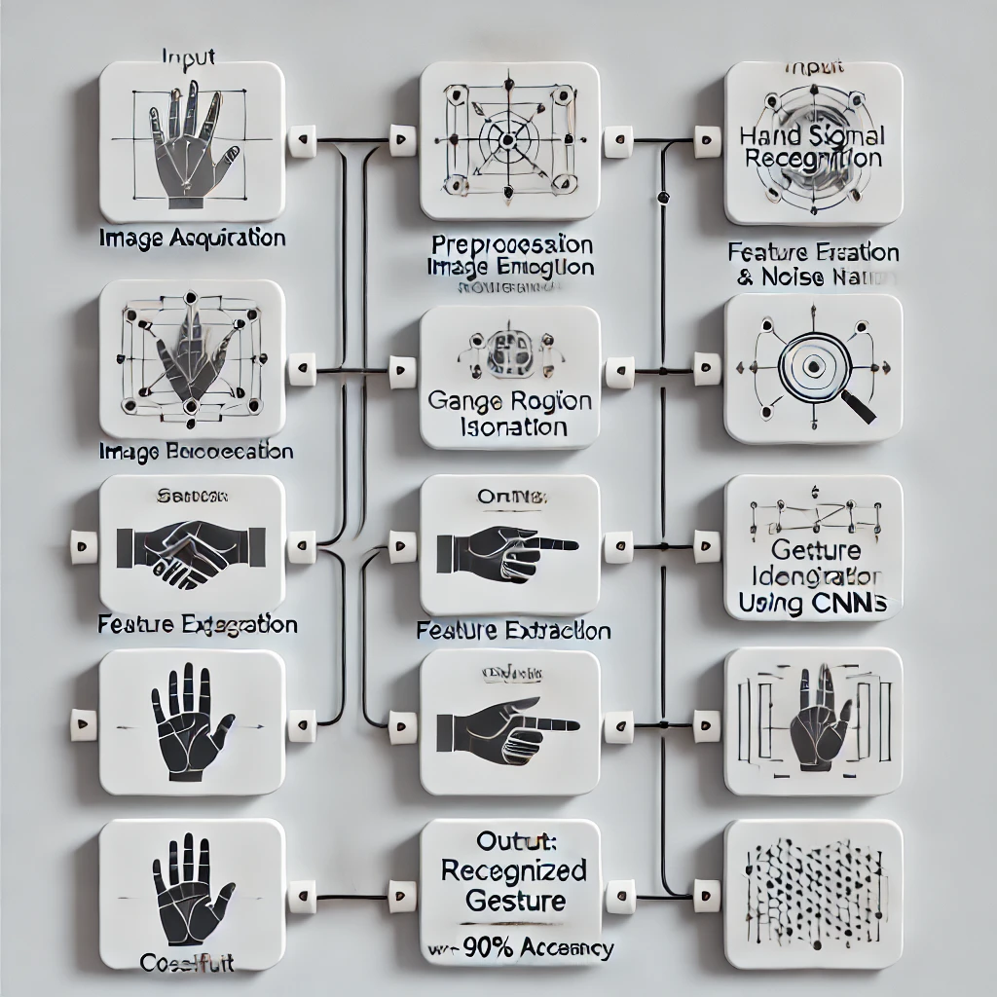

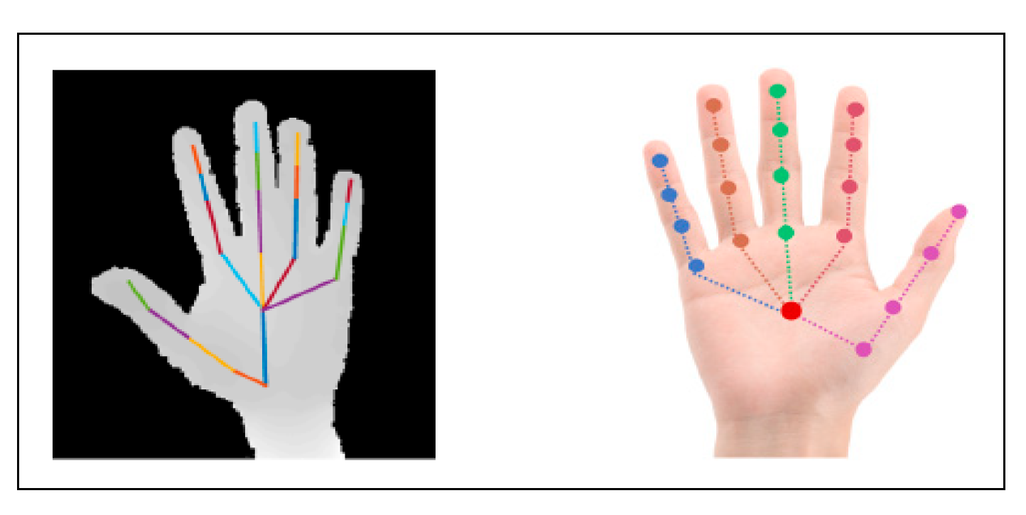

Here’s a detailed explanation of the working model for hand signal recognition in machine vision:

**1. Input: Image Acquisition**

* **Purpose**: Capturing the hand gesture.
* **Method**: A camera or any image-capturing device is used to acquire the image in real time or from a pre-stored dataset.
* **Considerations**: Ensure adequate lighting, proper background, and appropriate resolution for accurate processing.

**2. Preprocessing**

* **Purpose**: Prepare the image for analysis by enhancing quality and removing noise.
* **Techniques Used**:
  + **Image Enhancement**: Adjust brightness, contrast, and sharpness for clarity.
  + **Noise Reduction**: Use filters (e.g., Gaussian or median) to eliminate background noise.
  + **Normalization**: Resize images to ensure uniformity across the dataset.
* **Outcome**: A clean, normalized image ready for segmentation.

**3. Segmentation**

* **Purpose**: Isolate the hand region from the rest of the image.
* **Techniques Used**:
  + **Thresholding**: Convert the image to binary by separating foreground (hand) from the background based on pixel intensity.
  + **Edge Detection**: Use algorithms like Canny or Sobel to identify the boundaries of the hand.
  + **Region of Interest (ROI)**: Crop and focus only on the hand area.
* **Outcome**: A segmented image where the hand gesture is distinctly visible.

**4. Feature Extraction**

* **Purpose**: Identify unique features that characterize the hand gesture.
* **Techniques Used**:
  + Extract spatial, shape, and texture features such as contours, landmarks (key points like fingers), or histogram of oriented gradients (HOG).
  + Transform the segmented image into a format that captures essential gesture details.
* **Outcome**: A mathematical representation (feature vector) of the hand gesture.

**5. Classification**

* **Purpose**: Recognize the gesture by matching extracted features with predefined patterns.
* **Technique Used**: Convolutional Neural Networks (CNNs).
  + **Training**:
    - The CNN is trained using a large dataset of hand gestures.
    - Layers in the CNN automatically learn spatial hierarchies of features.
  + **Inference**:
    - The input features are passed through the trained CNN model.
    - The output layer assigns a probability score to each predefined gesture.
* **Outcome**: The gesture is classified based on the highest probability score.

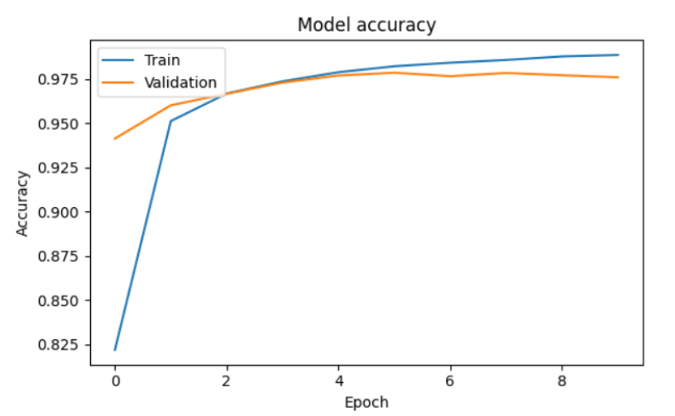

**Key Features of the Model**

1. **High Accuracy**: The use of CNNs ensures robust recognition of gestures, even in diverse conditions.
2. **Real-Time Processing**: Optimized for quick responses, making it suitable for interactive applications.
3. **Scalability**: Can be extended to recognize a larger set of gestures with additional training data.

This model exemplifies a seamless integration of image processing and deep learning for effective gesture recognition.

**Summary**

The system converts hand gestures into a digital format by systematically processing the input image through a sequence of machine vision techniques. From preprocessing to classification, every step ensures precise recognition, making the system suitable for intuitive human-computer interaction.

**Applications of the Model**

1. **Human-Computer Interaction**: Control systems using gestures (e.g., gaming, AR/VR).
2. **Assistive Technology**: Communication tools for individuals with speech impairments.
3. **Industrial Automation**: Gesture-controlled robots and machinery.
4. **Surveillance Systems**: Recognize distress signals in security footage.
5. **Sign Language Interpretation**: Automated translation of sign language into text or speech.

By combining precise preprocessing, feature engineering, and modern classification methods, this model achieves high reliability and accuracy for predefined gestures, paving the way for versatile real-world applications.